www.abroadgateway.com

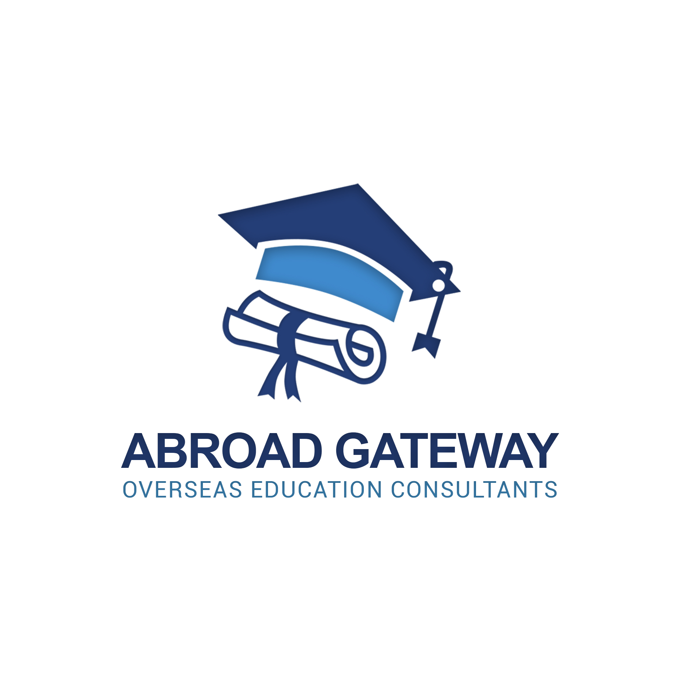

**POLAND: APPLICATION PROCESS**

STEP 1. Abroadgateway Consultants issues the following information for the benefit and convenience of the student:

• Polish Universities.

• Polish University School fees structures.

• Cost breakdown on living in Poland for International students.

• Package fees per University.

STEP 2. The prospective student takes time to go through the fee structures provided within 48 hours. Upon completion and review of University options the student may bring forth the following documents for assessment.

• Secondary school certificates or degree certificate & results slip.

• Copy of candidate’s passport.

• Certificate of the English language proficiency unless the high schooling was in English).

• Passport photo(soft copy).

Upon receiving of the documents, Abroadgateway Consultants will assess the student’s eligibility. If the student is eligible Abroadgateway Consultants will ask the student to pay the first installment of service fees from the package chosen.

STEP 3. After student has paid service fees Abroadgateway Consultants may commence with the processing of the student’s application and also offer post admission services to ensure the student is catered for as per our service package.

**Application Requirements** also includes the following: *Payment of application fees. *Student’s medical forms to be filled. *Accommodation selection. *Filling of application forms.